**Heroes and Dragons**

Noobisoft

**Contributions**

George Krutous: balance testing, documentation

Maggie Liu: game card aesthetics design, game revisions

Kelvin Lam: board design, balance testing, documentation

Ivan Zhao: illustrations, game revisions, documentation

**Game Play Description:**

The game setup begins with each player choosing a hero power, a hero token, 1 of each resource including gold, as well as a village center building card and encampment building card. Each person then start with 5 actions per turn for their hero which then they can spend by moving around the board, gathering events, trading with the bank, or constructing buildings. A daily event is in effect all the time and a new daily event replaces the old one whenever all players take a turn. As each player takes their turn, their wealth and power grows with buildings and items they can purchase. When 12 victory points is reached by any player, that player becomes the victor.

**Economic Activities:**

1. Accumulating resources and victory points are key components of the game. Since buildings require a variety of resources, players must gather many resources of all types in order to have a chance at winning. Thus accumulation is one of the very core components that make up this game. For players who prefer events and fighting the dragon, resources are not as important, but having resources would help since crafting them into items would boost your chances during events and dragon fights. Which brings me into my next point, only buildings and dragons give victory points. To win, the players must craft their resources into buildings that give bonuses and points. Though players may also craft items to help them win the game, using resources to give yourself a strong boost in the future can be seen as converting resources into strong benefits later on in the game. Conversion can also happen between resources if player has a trading stall. Trading stall allows the player to convert 4 of any resource to 1 gold and 1 gold can buy 1 of any resource. However the level 2 version market requires 3 resources while lv3 grand market requires only 2 resources. Having a market is basically a building that comes with conversion capabilities. We decided to make this building optional since this building mainly suit players of a specific play style of trading and resource management, while other players may want to collect resources for themselves and finding a market an investment not worth their price. Trade occurs when players with trading stalls agree to a mutual trade agreement. Whenever one player lacks a resource that other players have, demand for the resource fluctuate and trade occurs with different ratios depending on those demands and the supply available.
2. During gameplay, strategy and chance are both implemented in many ways. The teleporter tiles can help player move to their desired resource region so there is some control in planning your economy. At setup phase of the game the player can also choose a unique hero power which caters to different play styles too. For example The Meek Shall Inherit hero power gives a powerful bonus when player is behind, so that that new unconfident players would like this power. Silk Road power gives the player 1 gold from the bank whenever they make a trade with another player. This means they can dominate the market by giving the better deal than every other players offer when one player needs a resource, and still make a profit from it. IE, one player needs 1 stone, another player offers 1 stone for 1 food in return. Silk road offers the stone for free, and this trade would result in him getting 1 gold for the stone anyway. This power requires the silk road player to build a market to take advantage of this power or else he would hold a hand of gold which he can’t use. Chance occurs in this game dominantly in the dragon battle and event cards which are determined by dice rolls. A player may play safe and avoid the dragon and events the whole game to rely on their own strategy, but they’ll realize overtime that sometimes those risks are necessary to take, and those who take them can have a large advantage on those who don’t. Some events require all players to participate, so chance would be a part of their gameplay regardless of of their playstyle of strategy vs chance. When it comes to game play it is in the players strategic interest to gather all resources since every resource is necessary for buildings. Because all resources are required, players can not ignore a certain resource type and still expect to get ahead in the game. Different routes can be chosen within the map as well, but that is to give options for the player depending on what resources they need. Thus all resources must be used and all routes are taken.
3. Our game affords different player types because of the different kinds of strategies. For example, A person who likes to control the market into his favour would be a trader type player who interact with other players to get ahead. Players who like to take risks with events and fight against the dragon would require items to better their chances. And finally players who like to play safe and harvest resources at their pace would improve buildings which give actions or resources. Each type is not specifically good against the other, but each play style has ways to be played against. For example to play against the trade dominant player, agree to a trade pact with the other players to avoid giving him the benefit. For players who like to take risks, you can interfere with their roll with ingenuity item which can lower their roll by 1. For players who like to collect resources, they can be countered with the spy item which steals 2 resources from the player and inhibits the player from gathering a type of resource at users choice. We feel that this way it does not require on the player type to play against other players like other games, Runescape for example, where mages beat warriors, warriors beat archers, archers beat mages. This way we provide different play style so each player type can play against each other without an intrinsic handicap based on player type and strategy like runescape would have ie: mages would struggle against archers simply because mages have low defence and archers have high magic resist.

**Bartering/ Currency:**

Bartering can happen between players and with the bank. Since the buildings are quintessential to victory and require all types of resources to be built, it is in the players best interest to have a wide variety of resources. However since the land is divided into regions each with a dominant resource, it’s more likely for players to have quantity in 1 type of resource rather than in variety. This means players will generally have to trade with other players to achieve the variety of resources required for buildings. Since each game will have different players with different play styles, methods, and results, each game will have a different economy that's established through gameplay by the players. For example during one game food may be a scarcity and thus players may exchange 2 resources for food with each other, while in other games food may come in abundance and worth half as much as other resources, etc. Trade rules are inexplicit and the only concrete rule is that both players must agree on the trade. This means items can be traded among players. Other forms of negotiations may also occur and count as trade. For example a player draws an event card called war, which the player can use to fight another player, one player may bribe them with 1 gold not to attack them. In this case no actual physical object is bartered, but a sense of security is. (Unless the bribe acceptor is dishonourable and still goes to war with them)

Gold is a special type of resource that acts as currency within the game. They are often required for higher level buildings as well as crafting and trading with the bank. Once the player has built a trading stall, they can trade resources for gold and vice versa with the bank. Trading rates are harsh at first at low levels, but improve as the building improves. However if the player does not have a trading stall, they may trade with other players if they land on the same tile as the other players hero or village tile. Resources and gold as currency are also often gained or lost depending on events if the player chooses to explore them.

**Production Mechanism:**

Players acquire resources throughout the game by moving around the game board. There are different types of tiles represented on the board. When the player gets to a resource tile, he/she can spend an action point to collect the resource. Additionally, there are buildings that produce resources each turn. As a result, there is no chance for a deadlock because the player can always collect resources by simply moving around the board every turn. In early iterations of the game, we forgot that encampment counts as a building which limits the building cap, so that if a player forgot to upgrade their encampment, and used up their building slots, they can't build any buildings ever again. We decided to remove the encampment from the building capacity to eliminate this possibility of deadlock.

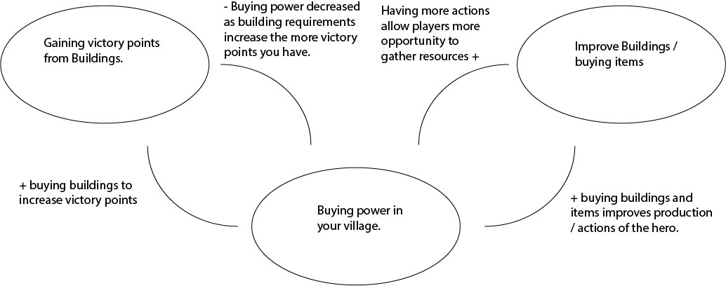

An example of a negative feedback loop is the upgrade cost of the buildings. Each step of the upgrade is more expensive than previous one. It was done to maintain the difficulty at a challenging level during the whole game. We felt that without this negative feedback loop, it’s too hard for players who are behind to catch up, and thus the rich get richer, etc.

The positive feedback loop can be seen in both items and buildings. Players can craft items to increase the actions of their hero which in return gives more opportunity to gather resources. Players may also improve buildings by paying its cost to upgrade its productivity. Many buildings will yield resources at the end of the players turn. Both methods will create more resources over time which means the more you buy, the stronger your buying power becomes.

**Revisions**

From play testing results we discovered many flaws within our initial game design, some tiny, some frustrating, but nothing drastically game breaking. Smaller issues would be things like clarity issues with wording in events and cards. Medium caliber issue would be too many elements to keep track of within the game which can be frustrating. The largest issue would be the game length.

One complaint we received was some players don't like events, so we made events optional by making it cost an action point to explore. This way players who dislike events can avoid them and important events can be saved for those who enjoy exploring narratives and taking risks.

During playtesting, we found a common frustration in our game. It was hard to keep track of all the actions and building bonuses. Before each turn had concrete rules, players often lose track of their actions and buildings. For example there is a hero power that gives an action every turn. Items, building upgrades, daily events, and random events can also give actions as well. Then if the player encounter an event, they have to count how many actions they have left all over again. Some buildings also give resources which players tend to forget to collect, or collect and then forget if they collected or not. Because of these issues we decided to create an instruction card with a concrete turn order: Count your actions available > use actions > collect resources from buildings at the end of the turn. Though this doesn’t eliminate the problematic post-event action counting, it is a step in the right direction. In a perfect world we would like to design some kind of action tracker with character cards or some sort of mobile app, but time was a heavy constraint on our project.

The biggest problem of game length was changed by reducing the required points to win. Originally we anticipated the game to ramp up in speed due to the resource producing buildings value over time, but we underestimated the initial phase of the game when those buildings don’t exist. This along with the time lost on counting turns and reading building requirements and events as well as learning the game caused a full game to last well into hours. Because of this we decided to cut the required points to win from 20 to 12. As we did this, we also had to rebalance other aspects of the game, such as the monument building and the dragons which gave obscene amount of victory points.

There was also a slight resource imbalance. We found that food was critical in almost all buildings and thus permanently important, while stone and ore are needed for upgrading buildings and wood was used the least. We decided to change building cost of a few cards to include wood and exclude food.

After all these changes, the next design questions would be are our resources balanced in terms of utility? Is game length adequate with the new 12 victory points requirement? Are there any areas we can further improve in terms of clarity? Does the new card format help players understanding of the game? Etc.

**Playtesting Details:**

The players who started at the stone and ore areas have an early game disadvantage because first level buildings require primarily food and wood. However, in the middle and late stages of the game these players will have more of an advantage.

The dragon event was rarely ever done because people preferred to walk around the board and collect resources as a safe option.

Game had too many elements to be remembered (how many actions do you have this turn, collect resources from buildings. Special hero powers, etc)

The original conditions to end the game did not work very well because 20 victory points were too many. As a result, we’ve reduced the required victory points to 12.

We have changed the board design a little bit to balance start condition but we still have four main areas with primary and secondary resource. For the dragon issue, we just increased the reward in ratio to stimulate players kill the dragon. This means that although this version of the game gives less victory points and resources than the previous dragon, the 8 less victory points required to win means the victory points are more meaningful, so ultimately dragon becomes more important even after being nerfed.

Games were generally balanced between players, no player got super ahead of other players. Dragon was the least used since with new players to games, they tend to avoid taking risks, though we believe the resources and points the dragon offers is abundant and fair considering the risk required when challenging it.

Some players were unhappy with random events that they felt it was beyond their control so we changed it to cost an action to explore the event, this way it leaves people who don’t want events alone, and leaves the good events for people who enjoys them. Event risk takers then caught on that they can get swords to influence their rolls during the events so that events are not completely out of their control when they build items.

**Session 1**

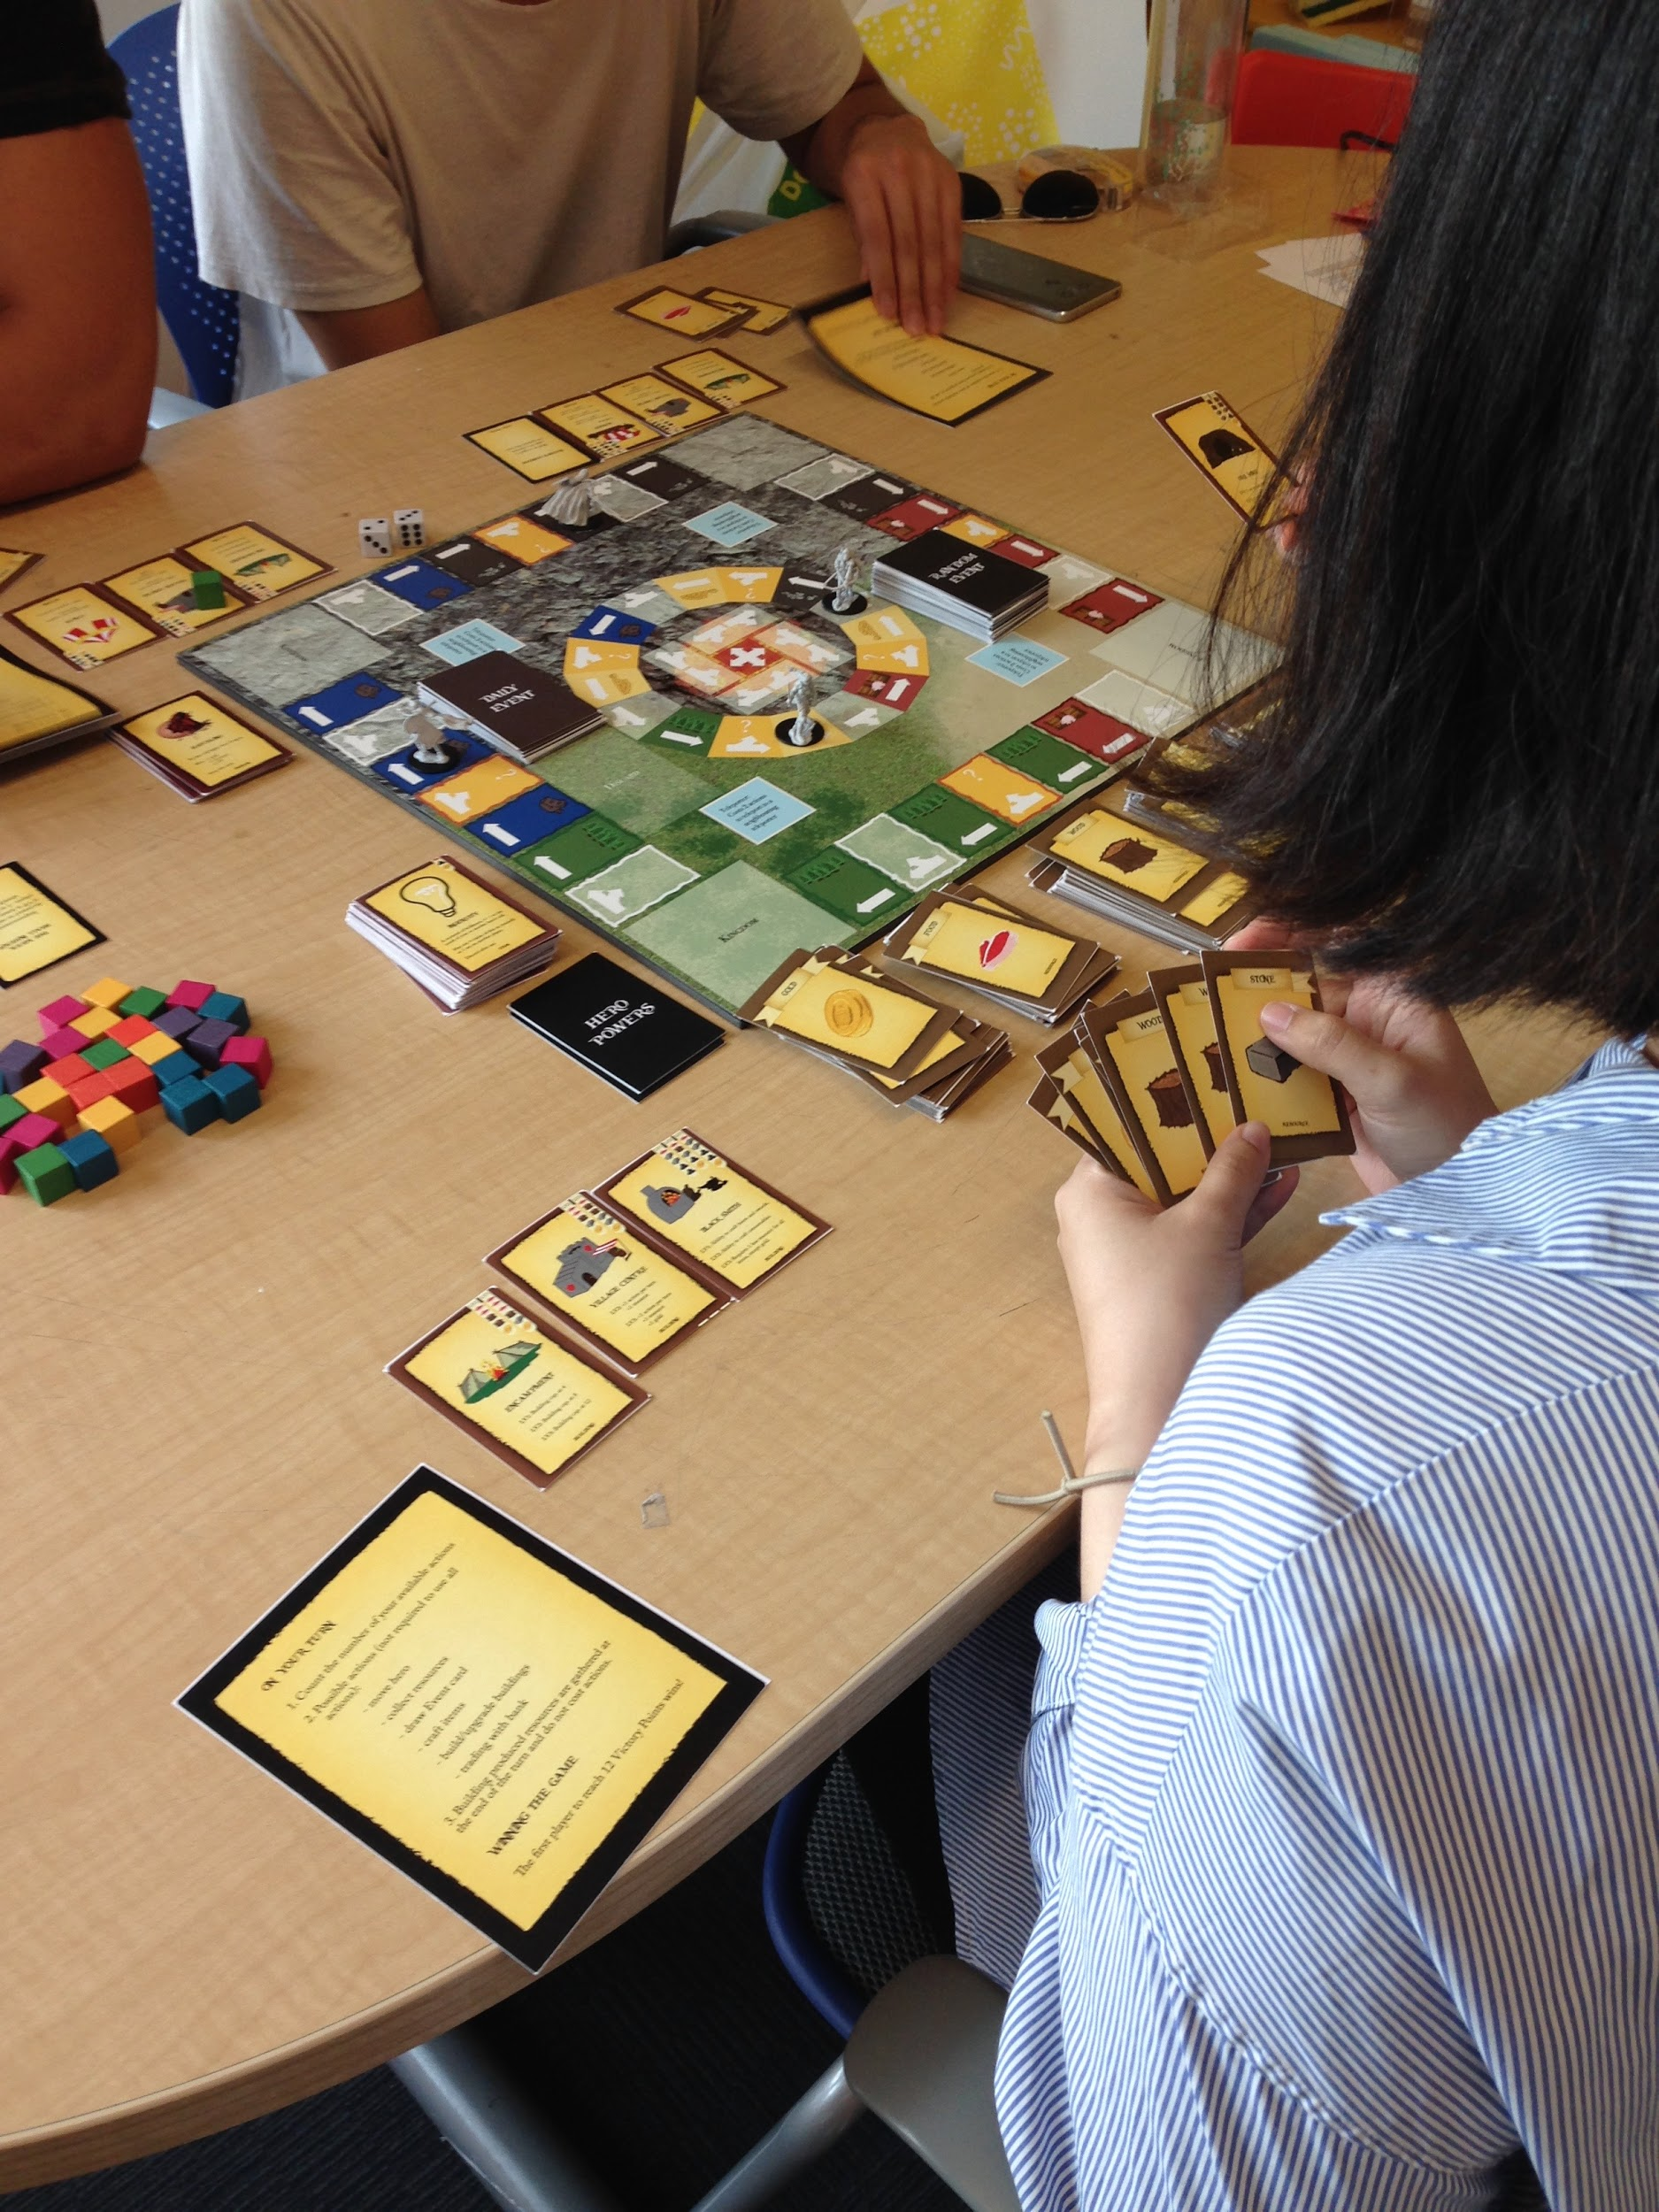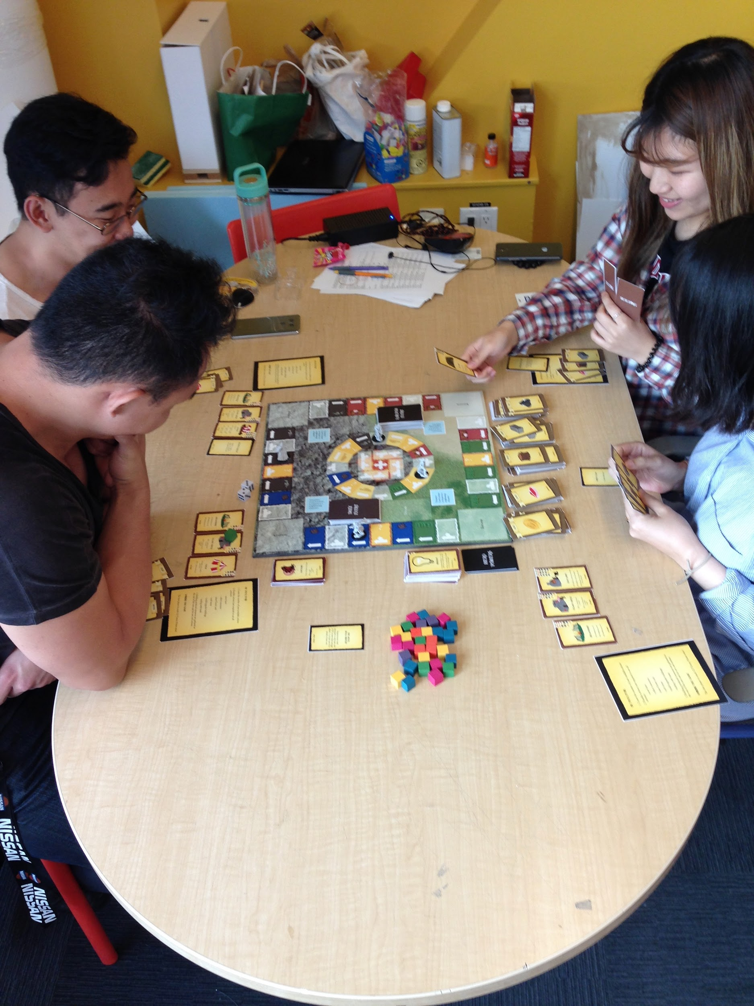

**Session 2**

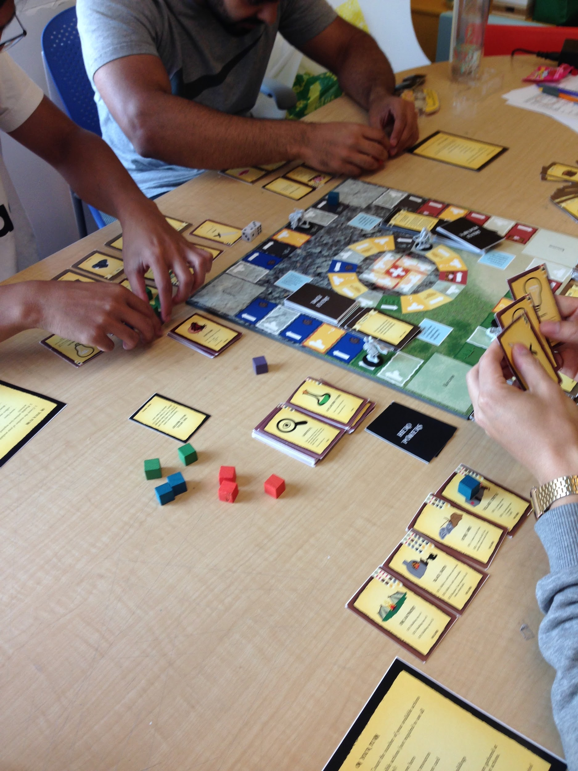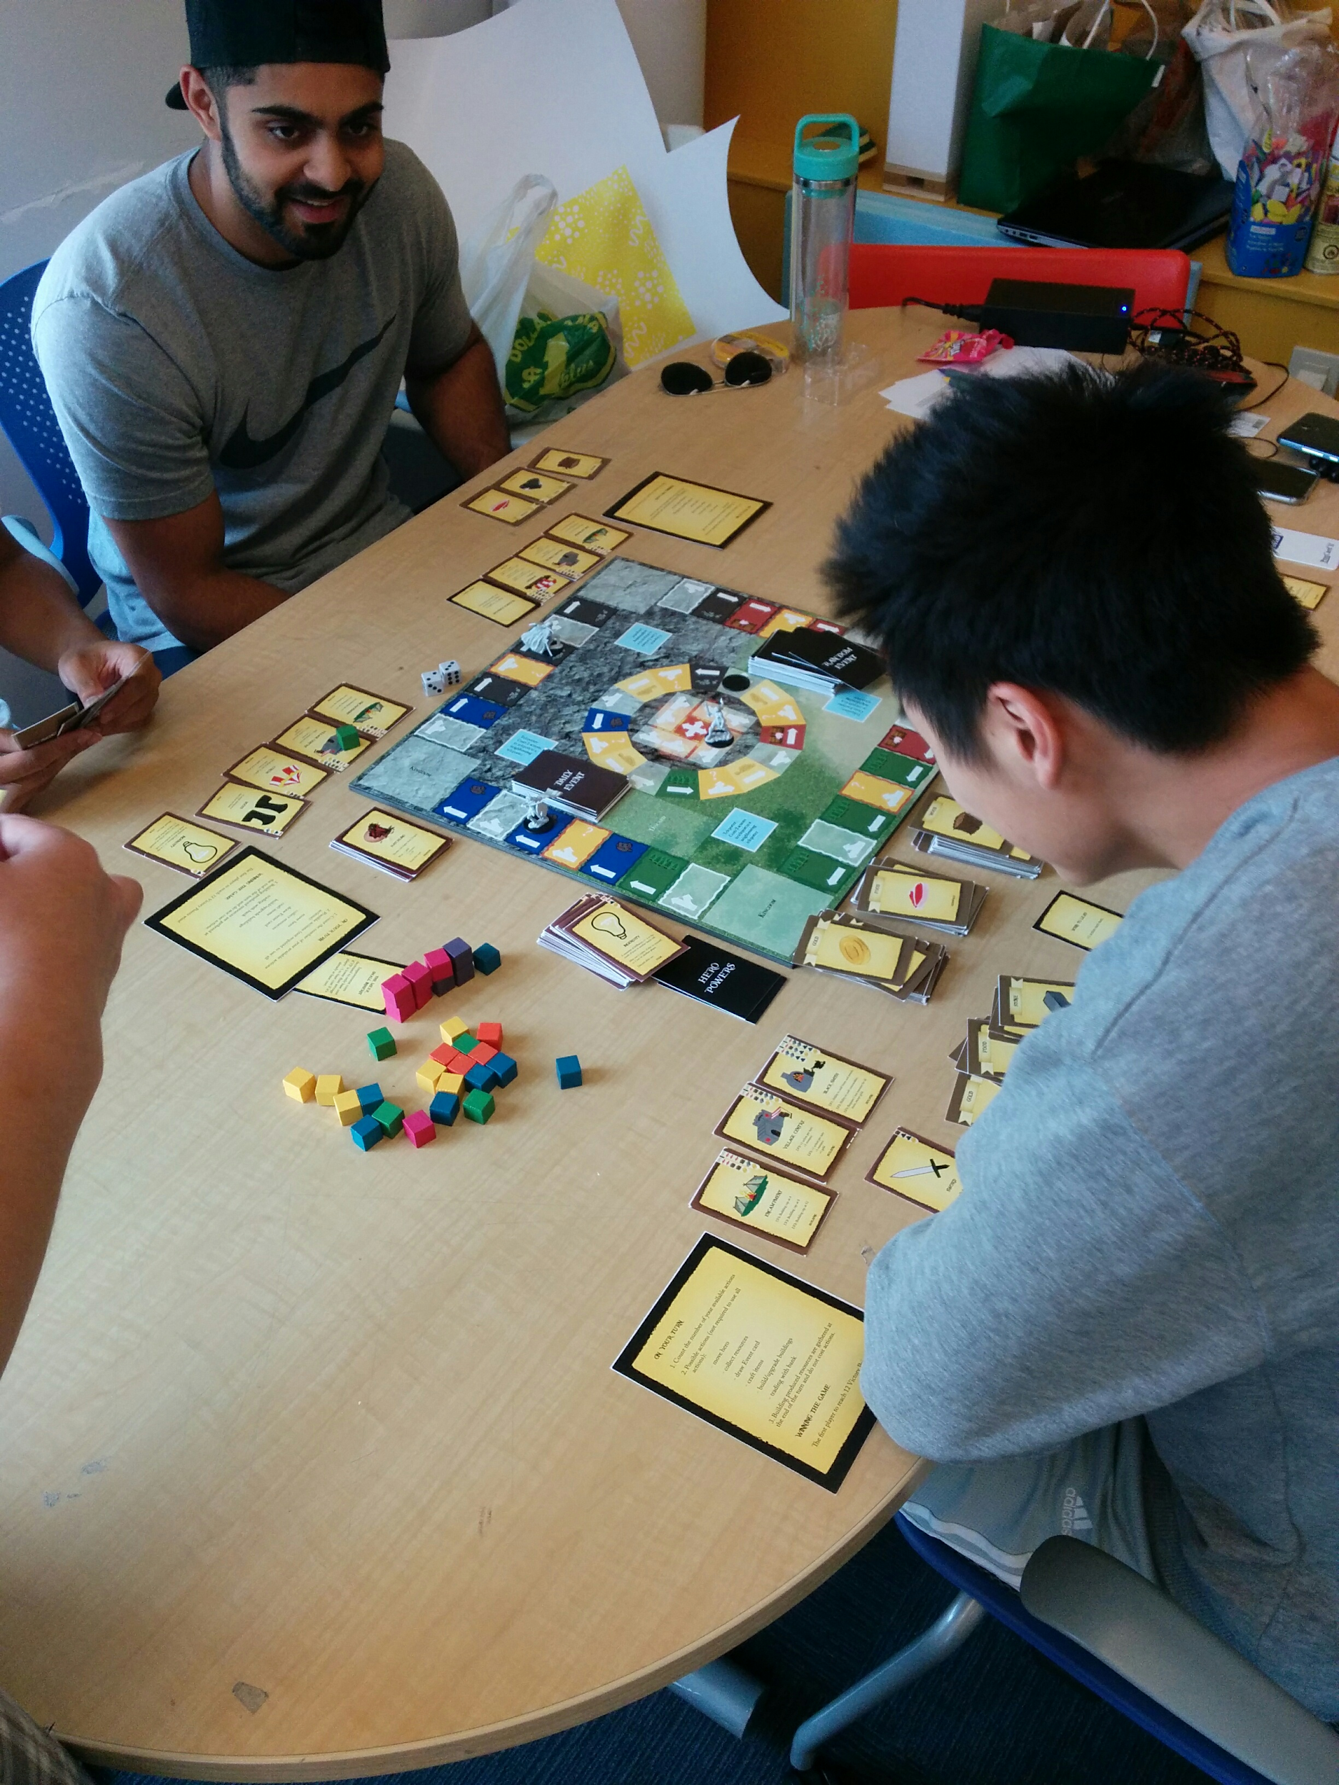

**Session 3**

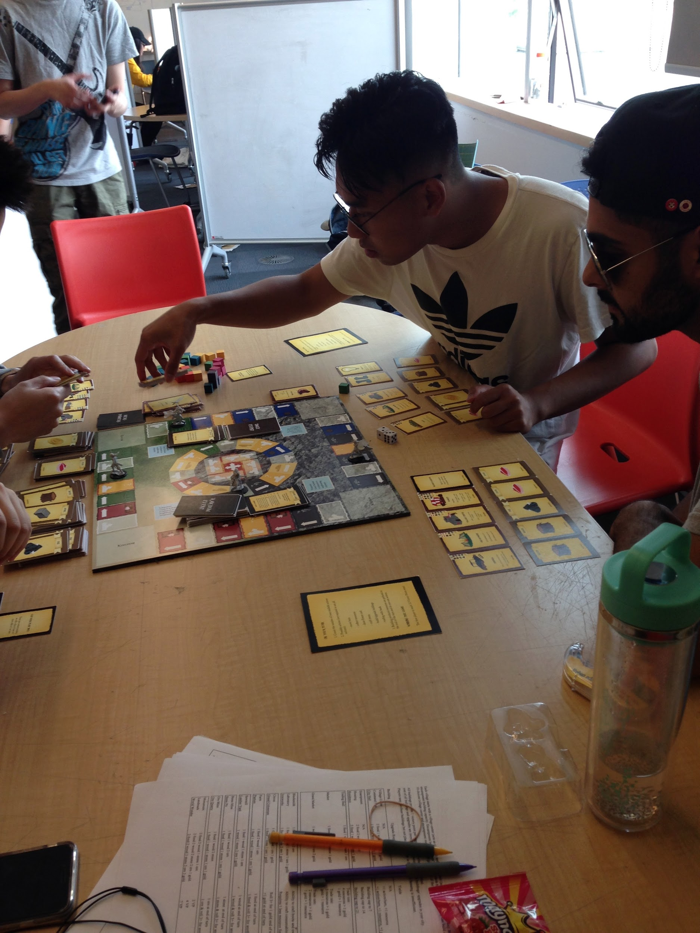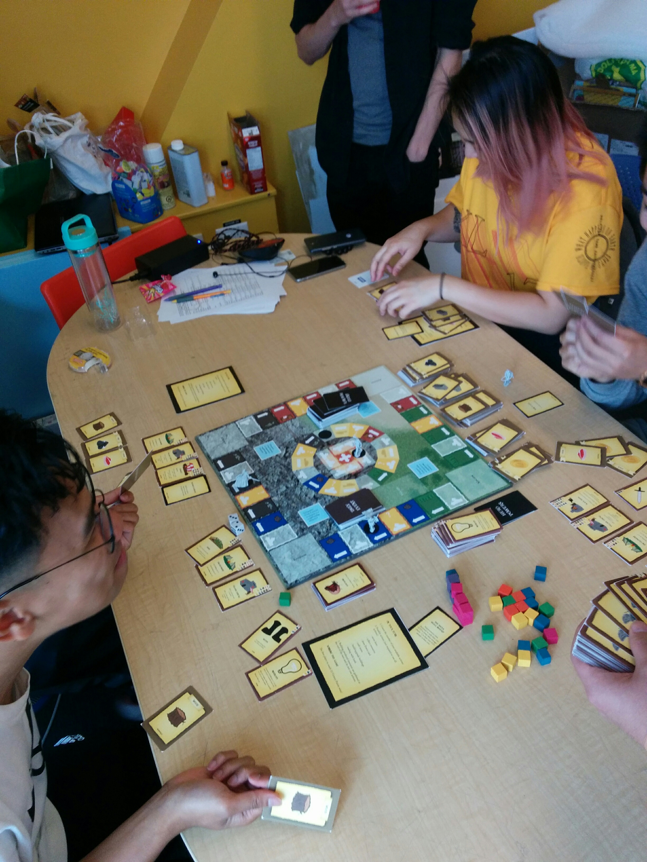

**Conclusion**

We feel that the final stage of our board game is interesting and offers players different ways of winning. However, it feels like the game still needs some balancing work to be done. Multiplayer games that are years old are still often patched with changes to keep the game interesting and balanced, Perhaps as the game receives more play in the future, we can continue to balance the game resources, strategies, and events.

**References**

Rock texture:

<http://www.ics.uci.edu/~djp3/classes/2015_03_ICS163/tasks/arMarker/Unity/arMarker/Assets/Terrain%20Assets/Textures/Cliff%20(Layered%20Rock).jpg>

Grass texture:

<http://www.ics.uci.edu/~djp3/classes/2015_03_ICS163/tasks/arMarker/Unity/arMarker/Assets/Terrain%20Assets/Textures/Grass%20(Meadows).jpg>

Dragon Hatchling: <http://www.khimeros.com/khimera_merger_tr/items/dragonhatchling4.png>

Dragon 2-6:

<http://img06.deviantart.net/c6b0/i/2017/063/8/a/hatchday__quest_ten___terror_of_the_draconic_seas_by_targonreddragon-db181nh.jpg>

Great wyrm dragon:

<http://vignette1.wikia.nocookie.net/forgottenrealms/images/8/84/Monster_Manual_5e_-_Dragon%2C_Red_-_p97.jpg/revision/latest?cb=20141112085614>